How to Fill GSTIN registration form
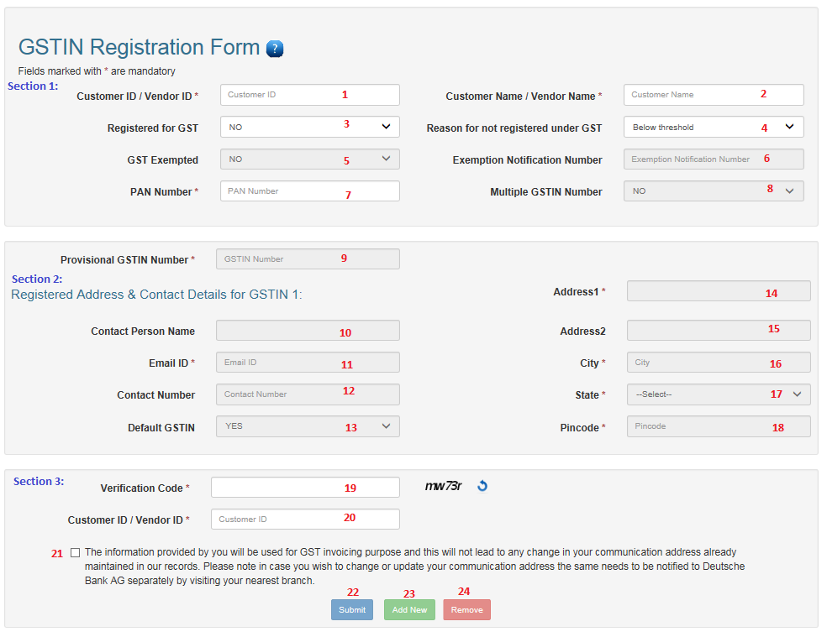
Section 1:
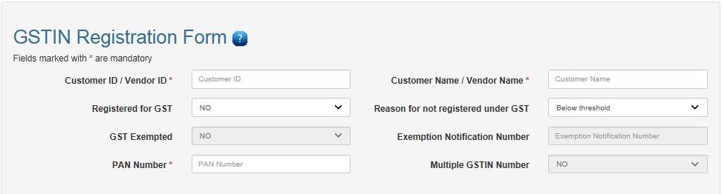
- Customer ID /Vendor ID:
  - If you are an existing Deutsche Bank Customer, then please enter your 9 digit Customer ID or 7 digit Master Number in this field.
  - If you are a Vendor associated with “Deutsche Bank” then enter 10 digit vendor ID in this field.
  - This is a Mandatory Field
- Customer Name/Vendor Name
  - Enter your Name/Company Name
  - This is a Mandatory Field
- Registered for GST
  - If you have registered for GST then select “Yes” otherwise select “No”
- Reason for not registered under GST
  - Select any one option drop down list for not registering with GST. If you have not registered for GST
- GST Exempt
  - If you exempt from GST then you have to select “Yes” otherwise “No”.
- Exemption Notification Number
  - If you are Exempted from GST then provide Exemption notification number
- PAN Number
  - Please enter 10 digit valid PAN Number.
- Multiple GSTIN Number
  - If you have Multiple GSTIN Number then Select “Yes” otherwise select “No”
Section 2:
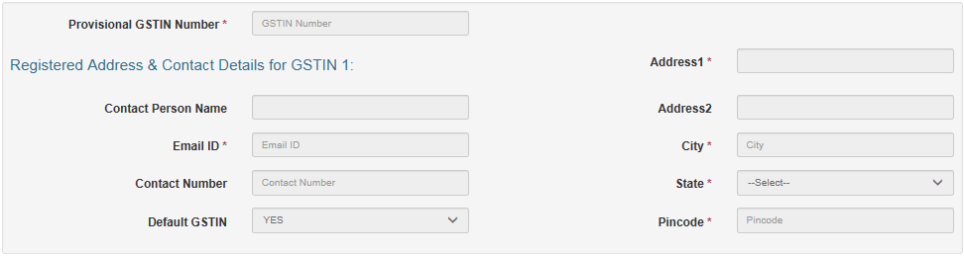
- Provisional GSTIN Number
  - The GSTIN Number is a 15 digit number provided by the Govt. Of India, once you have registered with GST.
  - Format for GSTIN Number
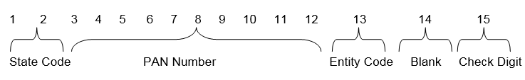
Eg.
27CRDPS0537E1Z0
First two digit should be state Code. State Code should be match with State Field (Refer State Master table)
27—State Code for Maharashtra
PAN number entered under the GSTIN (3-12 digit) should match with PAN Number entered in Section 1 PAN Number
- Contact Person Name
- Email ID
- Contact Number
- Default GSTIN
- If you have multiple business ventures, you would have been provided
  - If you have selected “Yes” in Multiple GSTIN Number then please select “Yes” in for your Default GSTIN in the GSTIN Number list.
Please provide registered address for GSTIN Number in below fields
- Address 1
- Address 2
- City
- State
- Pin code
Section 3:
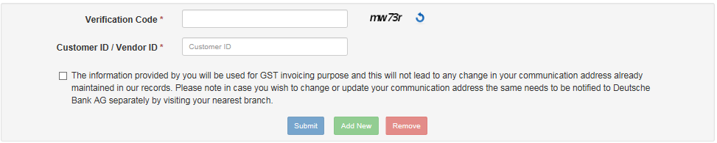
- Verification Code
  - you have to enter the captcha code displayed
- Customer ID / vendor ID
  - you have to re-enter Customer ID/vendor ID
- Declaration (Check Box)
  - You have to give confirmation that information will be used for GST invoicing purpose only.
- Submit (Button)
  - If you have checked the check box then only submit button become enable to submit GSTIN related information otherwise Submit button not enable for submission.
- Add New (Button)
  - If you have select Multiple GSTIN Number “Yes” then Add New button will be enabled to capture next GSTIN Number details.
  - Section 2 will need to be filled in for each GSTIN
- Remove (Button)
  - If you want to remove GSTIN number Details (Section 2)

If User is notregistered for GST
If User is not registered for GST then the user need to fill only highlighted fields.
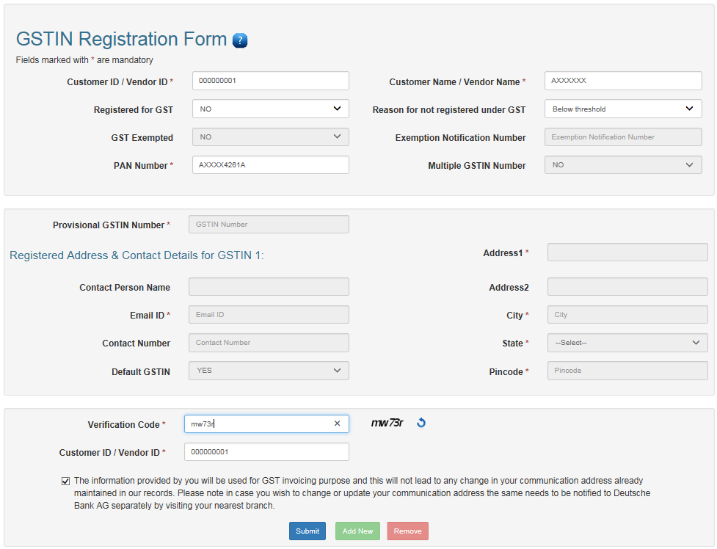

After Clicking on Submit button below screen will appear.

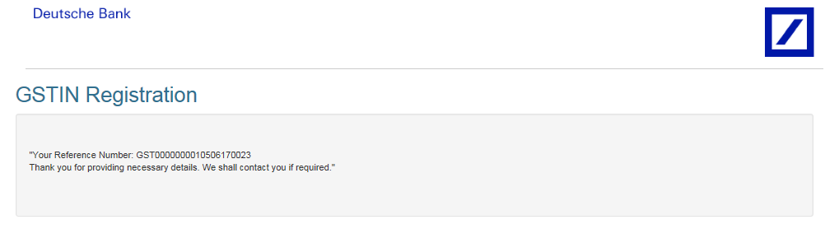

User having Single GSTIN Number
If you have single GSTIN Number then select “No” for Multiple GSTIN Number.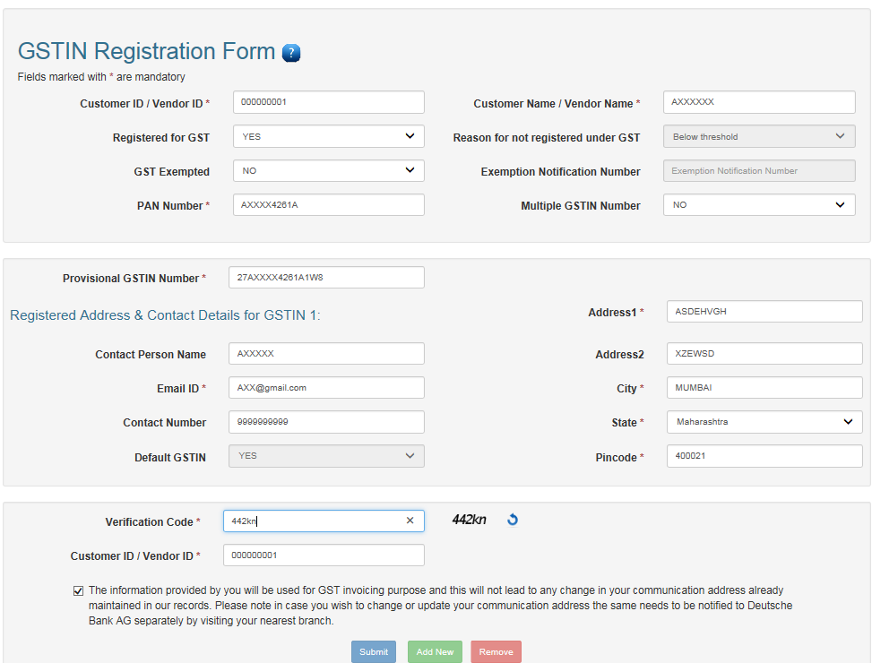

To Enter Multiple GSTIN Number
To Enter Multiple GSTIN Number then you have to select “Yes” for Multiple GSTIN Number.
Click on Add New Button then New Section for GSTIN 2 would appear where you able to enter next GSTIN details

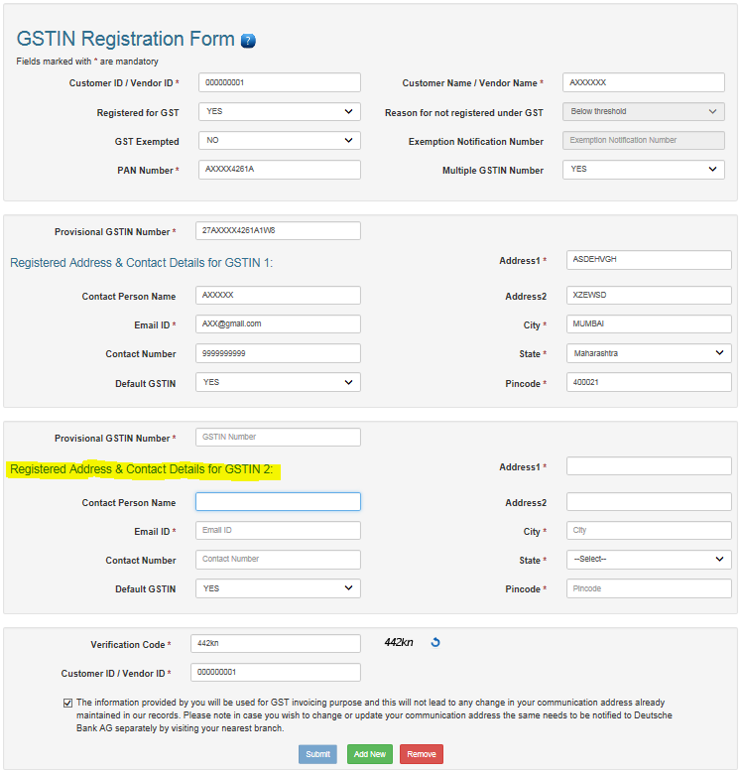
If you want to remove GSTIN2 number details from web form then click on Remove button.

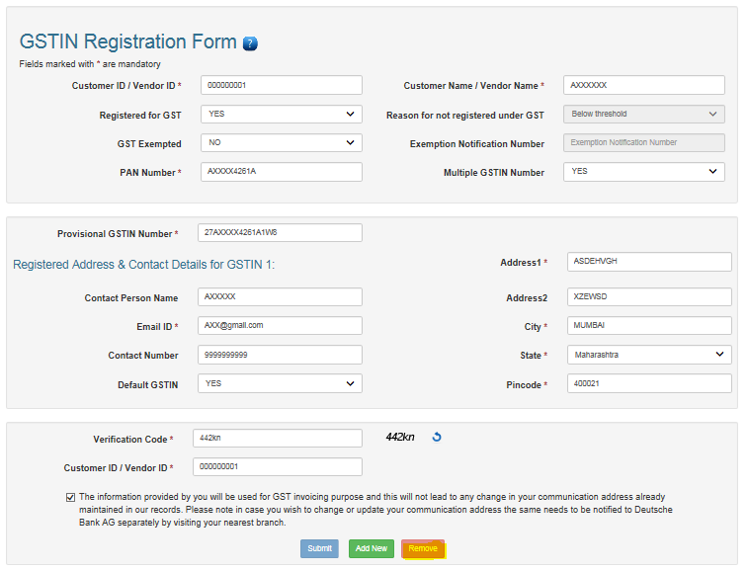

Table: State Master
Code | State Name & Union Territory | Type
01 | Jammu and Kashmir | State
02 | Himachal Pradesh | State
03 | Punjab | State
04 | Chandigarh | Union Territory
05 | Uttarakhand | State
06 | Haryana | State
07 | Delhi | Union Territory
08 | Rajasthan | State
09 | Uttar Pradesh | State
10 | Bihar | State
11 | Sikkim | State
12 | Arunachal Pradesh | State
13 | Nagaland | State
14 | Manipur | State
15 | Mizoram | State
16 | Tripura | State
17 | Meghalaya | State
18 | Assam | State
19 | West Bengal | State
20 | Jharkhand | State
21 | Orissa | State
22 | Chhattisgarh | State
23 | Madhya Pradesh | State
24 | Gujarat | State
25 | Daman and Diu | Union Territory
26 | Dadra and Nagar Haveli | Union Territory
27 | Maharashtra | State
28 | Andhra Pradesh | State
29 | Karnataka | State
30 | Goa | State
31 | Lakshadweep | Union Territory
32 | Kerala | State
33 | Tamil Nadu | State
34 | Puducherry | Union Territory
35 | Andaman and Nicobar Islands | State

